Software Design and Development Assignment 2

Cinema Enterpriso

Use Case Diagram

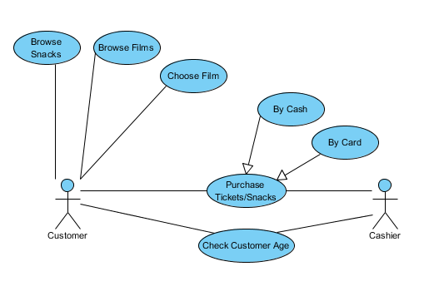

Class Diagram

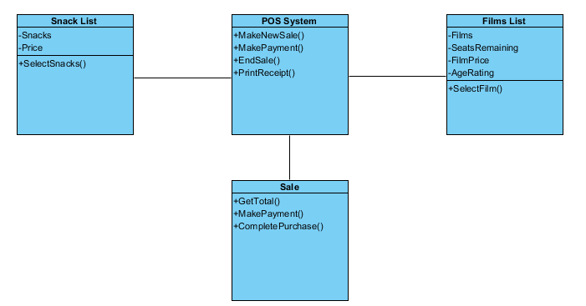

Notes

To keep my design simple yet efficient I have tried to minimalize the amount of stuff you will see on the systems screen. To do this I have created two separate areas to keep it simple one for the films which contains the films, the price of each film, the age rating of each film and the number of seats remaining for each film.

The second area contains the snacks that are available to purchase and their prices. Also on the screen there is a text box which is there to list off the items that are selected for purchase as you are going along. Beneath that there is also total cost box which shows the current total amount of money it will cost when paying.

Once the customer has chosen their film (and snacks if requested) then they will be taken to a screen which shows a receipt which contains the list of items they are purchasing and the total amount it will cost them.